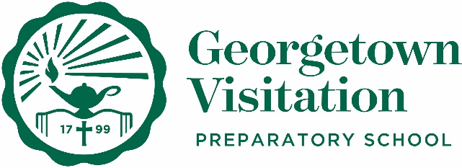

Average Cost per Student to Attend
Georgetown Visitation
2020-2021

2020-2021 Tuition | $32,600
Technology Fee | $200
Class Fee | $300
Uniforms | ~$350* | This estimate includes purchase of a new winter plaid kilt, summer green kilt, short-sleeve polo shirts, long-sleeve oxford shirts, pairs of GV socks, GV black fleece (optional), and shoes.  Visitation encourages families to participate in the “Used Uniform” program. Families can receive gently used uniforms. Contact Mrs. Raynetta Jackson-Clay via email at raynetta.clay@visi.org or by phone at 202-337-3350 ext. 2220 for more information.
Books | ~$450 - $700* | Visitation encourages families to order books in early July, when MBSdirect.com officially opens its online bookstore. Families who shop early are able to purchase used books at discounted prices. Visitation’s Parent Association also sponsors a used book swap and sale each year.
iPad | $500 - $1,088* | Students who receive over a certain amount of financial aid are included in the school-owned iPad program.
TOTAL | $34.400 - $35,238

*These costs are estimates and subject to change.

